# Quiz

1. Consider the given ER diagram below. Write the SQL code to create the schema.

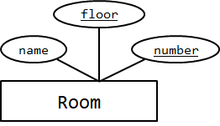

**Solution:**

CREATE TABLE Room (

floor integer,

number integer,

name varchar(100),

PRIMARY KEY (floor, number)

);

1. Consider the given ER diagram below. Write the SQL code to create the schema.

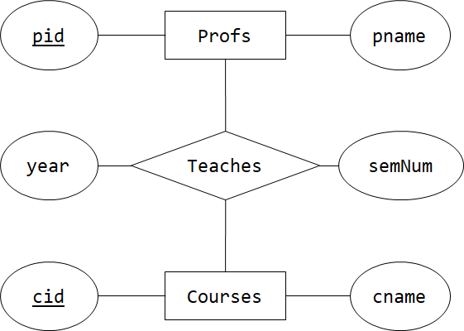

**Solution:**

CREATE TABLE Profs (

pid integer PRIMARY KEY,

pname varchar(100)

);

CREATE TABLE Courses (

cid integer PRIMARY KEY,

cname varchar(100)

);

CREATE TABLE Teaches (

pid integer REFERENCES Profs (pid),

cid integer REFERENCES Courses (cid),

year integer,

semNum integer,

PRIMARY KEY (pid, cid)

);

1. Consider the ER diagram below. Write the SQL code to create the schema.

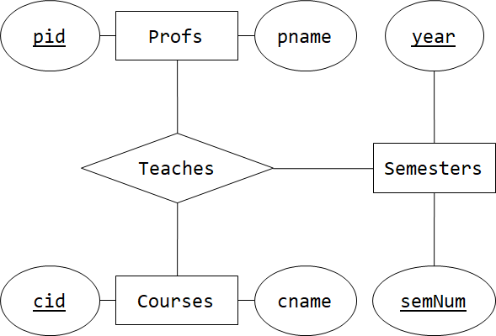

**Solution:**

CREATE TABLE Profs (

pid integer PRIMARY KEY,

pname varchar(100)

);

CREATE TABLE Courses (

cid integer PRIMARY KEY,

cname varchar(100)

);

CREATE TABLE Semester (

year integer,

semNum integer,

PRIMARY KEY (year, semNum)

);

CREATE TABLE Teaches (

pid integer REFERENCES Profs (pid),

cid integer REFERENCES Courses (cid),

year integer,

semNum integer,

FOREIGN KEY (year, semNum) REFERENCES Semester (year, semNum)

PRIMARY KEY (pid, cid, year, semNum)

);

1. You are creating a simple search engine. Your search engine works on a following schema R(phrase, result). You are tasked to search for all the result that contains the phrase ‘base’ anywhere in the phrase including the middle of the phrase.

**Solution:**

SELECT result FROM R WHERE phrase LIKE ‘%base%’;

1. Consider the following two schemas R(a,b) and S(c,d). You are to find all the distinct pairs (a,c) from R and S that satisfies a certain condition cond. Is the DISTINCT keywords necessary to ensure that the result will always be a distinct pairs (a,c)? An example SQL query is shown below.

SELECT ________ a,c FROM R, S WHERE cond.

**Solution:**

No, because a is the primary key of R and c is the primary key of S. Hence, a is unique in R and c is unique in S. This implies that the pair (a,c) is unique in R $×$ S.

1. Consider the definition of full outer join. Which of the following SQL query is equivalent to $π_{a,b}\left(R↔_{c}S\right)$?
   1. SELECT a,b FROM R FULL JOIN S ON c;
   2. SELECT a,b FROM R LEFT JOIN S ON c UNION SELECT a,b FROM R RIGHT JOIN S ON c;
   3. SELECT a,b FROM R RIGHT JOIN S ON c UNION SELECT a,b FROM R LEFT JOIN S ON c;
   4. ~~SELECT a,b FROM ( R LEFT JOIN S ON c ) RIGHT JOIN S ON c;~~ ***no left dangling tuple***
   5. ~~SELECT a,b FROM R LEFT JOIN ( S RIGHT JOIN S ON c ) ON c;~~ ***no right dangling tuple***
   6. SELECT a,b FROM R RIGHT JOIN S ON c UNION SELECT a,b FROM R LEFT JOIN S ON c UNION R JOIN S ON c;
2. You are given a simplified map where a city is represented as a square. The city hall is located right at the center of the city. We say that the city is at coordinate (0,0) since your schema is Map(x_coord, y_coord).

We use the notation (+,-) to denote that the x_coord is positive value and y_coord is negative value. We change the sign symbol correspondingly. We say that a house is in the first quadrant (Q1) if its coordinate is in (+,+), second quadrant (Q2) if its coordinate is in (-,+), third quadrant (Q3) if its coordinate is in (-,-), and the fourth quadrant (Q4) if its coordinate is in (+,-). You are guaranteed that there will be no houses on x_coord = 0 or y_coord = 0 as they are the two main roads on the city.

Write SQL query to output the quadrants of each set of coordinates in the Map.

**Solution:**

SELECT CASE

WHEN x_coord > 0 AND y_coord > 0 THEN ‘Q1’

WHEN x_coord < 0 AND y_coord > 0 THEN ‘Q2’

WHEN x_coord < 0 AND y_coord < 0 THEN ‘Q3’

ELSE ‘Q4’

END AS quadrant FROM Map;